Lithium-ion batteries for grid-scale storage

Contact information
Thomas Mandal Østergaard (tmo@ens.dk), Danish Energy Agency

Authors
Rasmus Rode Mosbæk (rasmus@hybridgreentech.com), Hybrid Greentech ApS
Søren Højgaard Jensen (soren@hybridgreentech.com), Hybrid Greentech ApS

Reviewer
Name, Affiliation

Content
Brief technology description 1
How does a Lihium-ion battery work? 1
Lithium-ion chemistries 3
Lithium-ion battery packaging 4
Components in a lithium-ion battery energy storage system 5
Input/Output 6
Energy efficiency and losses 6
Operational losses 6
Standby losses 7
Energy Efficiency 7
Regulation ability and other system services 8
Typical characteristics and capacities 9
Typical storage period 9
Space requirement 10
Advantages/disadvantages 10
Environment 10
Research and development perspectives 11
Examples of market standard technology 11
Prediction of performance and cost 13
Uncertainty 15
Data sheet 16
Acknowledgement 18
References 18

Brief technology description

How does a Lihium-ion battery work?
A lithium-ion battery or Li-ion battery (abbreviated as LIB) can store electric energy as chemical energy. Both non-rechargable and rechargeable LIBs are commercially available. The non-rechargable LIBs (also called primary cells) have long shelf-life and low self-discharge rates, and are typically fabricated as small button cells for e.g. portable consumer electronics, arm watches and hearing aids. Rechargeable LIBs (also named secondary cells) are applied in all kinds of consumer electronics, and is currently entering new markets such as electric vehicles and large-scale electricity storage. The rechargeable LIBs can be used to supply system level services such as primary frequency regulation, voltage regulation and load shifting, as well as for local electricity storage at individual households. Below we only focus on the rechargeable LIBs.

A LIB contains two porous electrodes separated by a porous membrane. A liquid electrolyte fills the pores in the electrodes and membrane. Lithium salt (e.g. LiPF₆) is disolved in the electrolyte to form Li⁺ and PF₆⁻ ions. The ions can move from one electrode to the other via the pores in the electrolyte and membrane. Both the positive and negative electrode materials can react with the Li⁺ ions. The negative electrode in a LIB is typically made of carbon and the positive of a Lithium metal oxide. Electrons cannot migrate through the electrolyte and the membrane physically separates the two electrodes to avoid electrons crossing from the negative to the positive electrode and thereby internally short circuiting the battery. The individual components in the LIB are presented in Figure 1.

Figure 1. Schematic diagram of a typical LIB system displaying the individual components in the battery.

When the two electrodes are connected via an external circuit the battery start to discharge. During the discharge process electrons flow via the external circuit from the negative electrode to the positive. At the same time Li⁺ ions leaves the negative electrode and flows through the electrolyte towards the positive electrode where they react with the positive electrode. The process runs spontaniously since the two electrodes are made of different materials. In popular terms the positive electrode “likes” the electrons and the Li⁺ ions better than the negative electrode.

The energy released by having one Li⁺ ion, and one electron, leaving the negative electrode and entering the positive electrode is measured as the battery voltage times the charge of the electron. In other words the battery voltage - also known as the electromotive force: EMF - measures the energy per electron released during the discharge process. EMF is typically a around 3-4 Volts and depends on the LIB cell chemistry, the temperature and the state of charge (SOC – see below). When e.g. a light bulb is inserted in the external circuit the voltage primarily drops across the light bulb and therefore the energy released in the LIB is dissipated in the light bulb. If the light bulb is substituted with a voltage source (e.g. a power supply) the process in the battery can be reversed and thereby electric energy can be stored in the battery.

The discharge and charge process is outlined in Figure 2. The battery is fully discharged when nearly all the Lithium have left the negative electrode and reacted with the positive electrode. If the battery is discharged beyond this point the electrode chemistries become unstable and starte degrading. When the LIB is fully discharged the EMF is low compared to when it is fully charged. Each LIB chemistry has a safe voltage range for the EMF and the endpoints of the range typically define 0% and 100% state of charge (SOC). The discharge capacity is measured in units of Ampere times hours, Ah, and depends on the type and amount of material in the electrodes.

Figure 2. Schematic diagram of a LIB system in charge and discharge mode. During discharge the green Li⁺ ions moves from the negative electrode (left side) to the positive electrode. The process is reversed during charge mode (right side).

The first lithium batteries were developed in the early 1970’ies and Sony released the first commercial lithium-ion battery in 1991. During the ‘90s and early 2000s the LIBs gradually matured via the pull from the cell-phone market. The Tesla Roadster was released to customers in 2008 and was the first highway legal serial production all-electric car to use lithium-ion battery cells. Further, around 2010 the LIBs expanded into the energy storage sector.

Lithium-ion chemistries
Table 1 shows a comparison of the three most widely used LIB chemistries for grid-connected LIB systems and the major manufactures. Other LIB chemistries such as LCO, LMO and NCA are not used for grid electricity storage and are therefore not included in the table. The numbers in the table are taken from cell manufactures, product or system suppliers. NMC is the most widely used of the three chemistries due to the increased production volume and lower prices lead by the automotive sector. The NMC battery has a high energy density but uses cobalt. The environmental challenges in using cobalt are described in the section: “Environment”.
The LFP battery do not use cobalt in the cathode, but are not as widely used as NMC, and are therefore generally higher priced, primarily due to the lower production volumes.
Both NMC and LFP batteries have graphite anodes. The main cause for degradation of NMC and LFP LIBs is graphite exfoliation and electrolyte degradation which in particular occur during deep cycling.
LTO LIBs are the most expensive cell chemistry of the three. In LTOs the graphite anode is replaced with a Lithium Titanate anode. The cathode of a LTO battery can be NMC, LFP or other battery cathode chemistries. The LTO battery is characterized by long calendar lifetime and high number of cycles.
Table 1. A comparison of four widely used LIB chemistries.
Short name | Name | Anode | Cathode | Energy density Wh/kg | Cycles | Calendar life | Major manufactures | References
NMC | Lithium Nickel Manganese Cobalt Oxide | Graphite | Li  Ni_{0.6}Co_{0.2}Mn_{0.2}O₂ | 120-300 | 3000-10000 | 10-20 years | Samsung SDI  LG Chem  SK Innovation  Leclanche  Kokam | [1–5]
LFP | Lithum Iron Phosphate | Graphite | LiFePO₄ | 50-130 | 6000-8000 | 10-20 years | BYD/Fenecon  Fronius/Sony* | [6,7]
LTO | Lithium Titanate | LiTO₂ | LiFePO₄ or Li  Ni_{0.6}Co_{0.2}Mn_{0.2}O₂ | 70-80 | 15000-20000 | 25 years | Leclanche  Kokam  Altairnano | [1,3,4,8]

*Residential energy storage system. All other systems are multi-MWh size.

Lithium-ion battery packaging
The most common packaging styles for LIB cells are presented in Figure 3. Examples are provided in Figure 4. Figure 3(a) show a schematic drawing of a cylindrical LIB cell. Cylindrical cells find widespread applications ranging from laptops and power tools to Tesla’s battery packs. Figure 4(a) shows Tesla’s 21700 cylindrical LIB cell which is 21 mm in diameter and 70 mm in length. The cell is produced in Tesla’s Gigafactory 1 for Tesla Model 3 [9]. Figure 3(b) outline a coin LIB cell. Coin cells are usually used as primary cells in portable consumer electronics, watches and hearing aids. Since they are not used for secondary cells (rechargeable) in grid-connected LIB Battery Energy Storage Systems they are not described further in this text. Figure 3(c) displays a schematic drawing of a prismatic LIB cell. Prismatic LIB cells are often used in industrial applications and grid-connected LIB Battery Energy Storage Systems. The Samsung SDI prismatic LIB cell is shown in Figure 4(b). This cell type is used in the BMW i3 [10]. Figure 3(d) shows a schematic drawing of a pouch LIB cell. Figure 4(c) shows an LG Chem pouch NMC LIB cell used in LG Chem’s grid-connected LIB Battery Energy Storage Systems. Pouch LIB cells are also used in electric vehicles such as the Nissan Leaf [11].

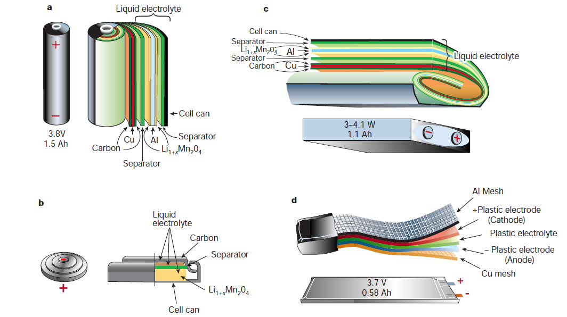
Figure 3. Schematic drawing showing the shape, packaging and components of various Li-ion battery configurations [12]. (a) Cylindrical; (b) coin; (c) prismatic; and (d) pouch.

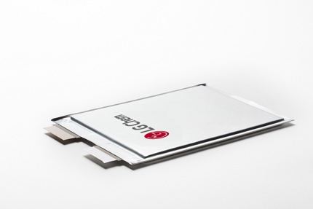
Figure 4. Examples of LIB cells. (a) Tesla 21700 cylindrical NMC LIB cell [13]. (b) Samsung SDI prismatic LIB cells [14]. (c) LG Chem pouch NMC LIB cell [15].

Components in a lithium-ion battery energy storage system
Figure 5 provides an overview of the components in a LIB storage system with interface to the power grid. In LIB storage systems battery cells are assembled into modules that are assembled into packs. The battery packs include a Battery Management System (BMS). The BMS is an electronic system that protects the cells from operating outside the safe operating area. A Thermal Management System (TMS) regulates the temperature for the battery and storage system. The TMS depends on the environmental conditions, e.g. whether the system is placed indoor or outdoor. Further an Energy Management System (EMS) controls the charge/discharge of the grid-connected LIB storage from a system perspective. Depending on the application and power configuration the power conversion system may consist of one or multiple power converter units (DC/AC link). For system coupling a transformer may be needed for integration with higher grid voltage levels. The grid integration provides services to the grid such as increased reliability, load shifting, frequency regulation etc. The services are described further below in the section “Regulation ability and other system services”. Value generation and profit is created by selling the services to grid Transmission System Operators (TSOs). Appropriate sizing of the battery and power conversion systems is essential to maximize the revenue. Technical and economic aspects of a battery storage system, system coupling and grid integration are summarized in Table 2.

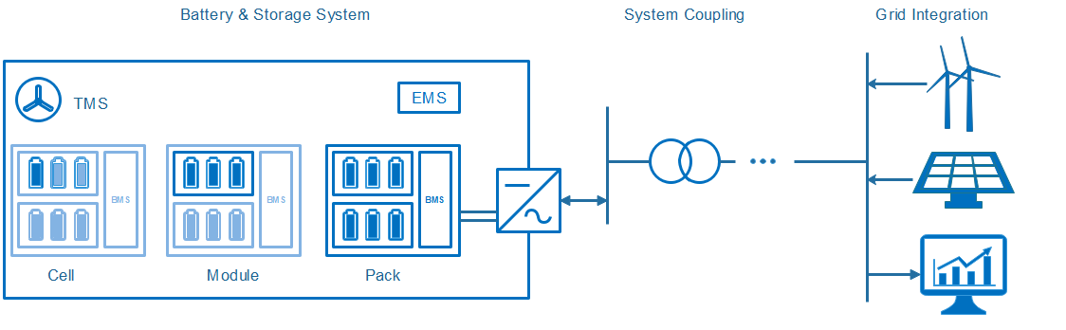
Figure 5. Schematic drawing of a battery storage system, power system coupling and grid interface components. Keywords highlight technically, and economically relevant aspects. Modified from [16].

Table 2. Formalized overview of the battery storage system, power system and grid interface components considering both technical and economic aspects. Modified from [16].
 | Battery & Storage System | System Coupling | Grid Integration
Technical | Battery System (Cell, Module, Pack)  Battery Management System (BMS)  Energy Management System (EMS)  Thermal Management System (TMS) | Power Electronics (AC/DC) & Transformer  Environmental Conditions | Application Specific Profile  Local Connection /  Grid Level of Integration
Economic | CAPEX: Battery system and sizing OPEX: Degradation and Efficiency  Operation Control Strategy | CAPEX: Power Electronics/ Placement of System  OPEX: Conversion Efficiency | CAPEX: Regulatory Framework  OPEX: Regulatory Framework Profit / Savings via Application

Input/Output
Input and output are both electricity. Electricity is converted to electrochemical energy during charge and converted back to electricity during discharge in the reaction process described in the section: “How does a Lithium-ion battery work?”.

Energy efficiency and losses
The losses in a LIB can be divided in operational and standby losses. The operational losses are first described, then the standby losses. Finally the energy efficiency is discussed.
Operational losses
The operational losses occur when energy is discharged or charged to/from the grid. It includes the conversion losses in the battery and the power electronics.
When the LIB is not operated its voltage U equals the EMF. However, during discharge or charge the battery voltage U change due to current I passing the internal resistance R_{i} in the LIB. The voltage change ΔU can be described using Ohms law
and the loss in the internal resistance is defined as
Equation explains how the loss increases with increasing current.
The LIB provides a DC current during discharge and needs a DC current input for charging. Before the electricity is sent to the grid the inverter converts the DC current to AC. The inverter loss typically increases gradually from around 1% to 2% when increasing the relative conversion power from 0% to 100% [17].
Standby losses
Unwanted chemical reactions cause internal current leakage in the LIB. The current leakage leads to a gradual self-discharge during standby. The self-discharge rate increases with temperature and the graph below shows the remaining charge capacity as function of time and temperature for a LIB. The discharge rate is the slope of the curve and is around 0.1% per day at ambient temperature.

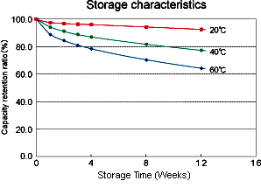
Figure 6. Remaining charge capacity for a typical LIB as function of storage time [18].
Besides the self-discharge in the cell, a LIB electricity storage system requires power to operate the auxiliary balance of plant (BOP) components. Figure 5 outlines the BOP components which include the inverter, BMS, EMS and TMS. The relative energy loss to the BOP components depends on the application, and a careful operation strategy is important to minimize their power consumption [17]. The standby loss is the sum of the energy losses during standby due to self-discharge and power consumption in the BOP components.
Energy Efficiency
The conversion roundtrip efficiency of the LIB cell is the discharged energy divided with the charged energy. The battery conversion efficiency decreases with increasing current since the increases. An example of a LIB cell conversion efficiency is shown in Figure 7. The C-rate is the inverse of the time it takes to discharge a fully charged battery. At a C-rate of 2 it takes ½ hour and at a C-rate of 6 it takes 10 minutes.

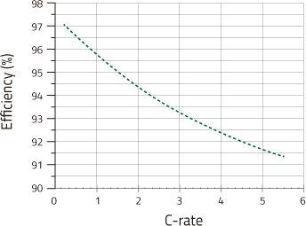
Figure 7. Conversion round trip efficiency vs. C-rate for one of Kokam’s NMC-based lithium polymer batteries [19].
The system conversion roundtrip eﬃciency considers losses which occur on the conversion path from the energy charged and the energy discharged from/to the grid. It includes the conversion losses in the battery and power electronics
and can be written as
The total roundtrip eﬃciency further includes the standby losses:
Here denotes the energy required from the grid to continuously operate BOP and maintain state of charge. The various types of losses makes heavily dependent on the application. As an example, an 11 MW/4.4 MWh LIB system was installed in Maui, Hawaii for wind ramp management, essentially smoothing the output of an 21 MW wind farm [20]. The total roundtrip eﬃciency for this system is around 80 % [21]. Lazard uses an estimate of 85% [22]. To summarize, the total roundtrip loss typically consist of 2-5% related to the cell, 2-4% to the power electronics and the rest to standby losses.

Regulation ability and other system services
Grid-connected LIBs can absorb and release electrical energy fast. The response time of grid-connected LIBs are strongly dependent on control components, EMS, BMS and TMS as well as the power conversion system.
The relatively low electricity storage costs makes grid-connected LIB BESS (Battery Energy Storage System) suitable for a broad range of applications [23] such as peak load shaving where the BESS provides or consumes energy to reduce peaking in a power system. In relation to this BESS can promote renewable integration, e.g. time or load shifting of photovoltaic power from day to night. Further the BESS can provide transmission congestion relief where locally deployed BESS reduces the load in the transmission and distribution system. In this way the BESS can help defer expensive upgrades of the transmission and distribution network.
The fast response time enables the use of BESS for a broad range of primary control provisions. These include Frequency regulation where the BESS are used to alleviate deviations in the AC frequency. The BESS can also be used to improve network reliability by reacting immediately after a contingency. Here the BESS can help maintaining stability in the power system until the operator has re-dispatched generation. Moreover, the BESS can effectively be used for black-starting distribution grids and BESS systems are suitable for enhancing the power quality and reducing voltage deviations in distribution networks. The BESS can further be used to provide spinning reserves and regulate active and reactive power thereby improving the network voltage profile. This can improve the integration of renewable energy because it reduces the events triggering the protections of the inverters.

Typical characteristics and capacities
The frame or shelf that holds the batteries is called a rack, i.e. it is the battery pack (Figure 5) without the BMS. The energy per rack is typically 60-166 kWh [2,24] and the size is e.g. 415mm x 1067 mm x 2124 mm (W x D x H) for a 111kWh rack from Samsung SDI [2] and 520 mm x 930 mm x 2200 mm (W x D x H) for a 166.4 kWh rack from LG Chem [24]. The weight of the Samsung SDI rack is 1170 kg and the C-rate is 0.5 during charge and up to 6 during discharge [2]. For the LG Chem system the weight is 1314 kg. This gives an energy density of 118 kWh/m³ and 0.095 kWh/kg for the Samsung SDI system and 156 kWh/m³ and 0.127 kWh/kg for the LG chem system The C-rate for the LG Chem systems ranges from around 0.3 to +1 but is not specified in detail. For this reason the Samsung SDI system is used to specify energy and power density in the data sheet (Table 3). For the Samsung SDI system the power density in charge-mode is 50 kW/m³ and 0.047 kW/kg. In discharge-mode it is 708 kW/m³ and 0.569 kW/kg.

Typical storage period
Several aspects of the LIB technology put an upper limit to the feasible storage period. The self-discharge rate makes storage periods of several months unfeasible. The BOP power for standby operation adds parasitic losses to the system which further limits the feasible standby time. Unwanted chemical reactions in the LIB gradually degrade the battery and limit the calendar lifetime. This calls for shorter storage periods in order to obtain enough cycles to reach positive revenue.
For LIBs the total number of full charge-discharge cycles within the battery lifetime is limited between a few thousands up to some ten-thousands. The exact number depends on the chemistry, manufacturing method, design and operating conditions such as temperature, C-rate and calendar time. This impacts the type of suitable applications. For instance due to the different degree of usage, the LTO chemistry may find more use on the FCR-N market while others like NMC may be preferred for the FCR-D market.
Until now the majority of the current LIB systems have been deployed to perform fast reactive renewables smoothing and firming with storage periods ranging from seconds to minutes [25]. But more recently, the systems are increasingly used for renewables time shifting with typical storage periods of a few hours [17,25].

Space requirement
The racks and battery packs are assembled in containers and the energy per 40 feet container is 4-6MWh for NMC batteries [2,24]. The foot-print of a 40-feet container is 29.7 m². This gives a space requirement around 5-7.5 MWh/m².

Advantages/disadvantages
Within the last decade the commercial interest for electricity storage using LIB systems has increased dramatically. The production volume is still limited and there is a promising potential for cost reductions through upscaling. The technology is stand-alone and requires a minimum of service after the initial installation.
Containers come in standard sizes. For small systems this impacts the LIB system CAPEX, however when the system size exceed several container units, the price can be considered fairly linear. Compared to e.g. fuel cell technology the CAPEX per storage capacity is relatively high. This is because the electricity is stored in the battery electrodes whereas for fuel cells the electricity is stored as a separate fuel. The relatively high energy specific CAPEX combined with the gradual self-discharge and parasitic losses in the BOP make the technology less attractive for long-term storage beyond a few days.

Environment
A US-EPA report stated in 2013 that across the battery chemistries, the global warming potential impact attributable to LIB production including mining is substantial [26]. More specifically a recent review on life-cycle analysis (LCA) of Li-Ion battery production estimates that “on average, producing 1 Wh of storage capacity is associated with a cumulative energy demand of 328 Wh and causes greenhouse gas (GHG) emissions of 110 g CO_{2 eq}“ [27].
The LIB cathode material NMC contains toxic cobalt and nickel oxides. About 60% of the global production of cobalt comes from Congo and the environmental health risks and work conditions in relation to the cobalt mining rises ethical concerns [28]. Visual capitalist believes the cobalt content in NMC could decrease to 10% already in 2020 [29].
Starting about two years ago, fears of a lithium shortage almost tripled prices for the metal [30]. Demand for lithium won’t slacken anytime soon - according to Bloomberg New Energy Finance the electric car production alone is expected to increase more than thirtyfold by 2030. However, the next dozen years will drain less than 1 percent of the reserves in the ground, BNEF says. But battery makers are going to rapidly increase mining capacity to meet the demand.

Research and development perspectives
Currently a wide range of government and industry-sponsored LIB material, cell and system level research is taking place. Some of the ongoing material research to further increase the energy density of LIB cells includes high-voltage electrolytes allowing charging voltages of up to 5 volts [31] and silicon nanoparticle based anodes to boost the charge capacity [32]. Several research and development activities focus on improving the cycle lifetime of LMO cells [33–35].
Some of the most promising post Li-ion technologies include Lithium Sulphur batteries that use Sulphur as an active material. Sulphur is abundantly available at reasonable price and allows for very high energy densities of up to 400 Wh/kg. Also Lithium air batteries have received considerable attention. Since one of the active materials, oxygen, can be drawn from the ambient air, the lithium-air battery features the highest potential energy and power density of all battery storage systems. Due to the existing challenges with electrode passivation and low tolerance to humidity, large-scale commercialization of the lithium-air battery is not expected within the next years.
Several non-lithium-based battery chemistries are being investigated. Aluminum Sulphur batteries may reach up to 1000 Wh/kg with relatively abundant electrode materials, but are still in the very early development phase [36].
Besides the materials research, improved cell design, BMS, TMS and EMS technology and operation strategy can improve storage efficiency considerably [17].
Although LIB systems for electricity storage are now commercially available, the R&D is still in its relatively early phase and is expected to contribute to future cost reductions and efficiency improvements.

Examples of market standard technology
Grid scale turn-key LIB systems are commercially available from a wide range of suppliers. Referenced examples are shown in Table 3. Two larger grid-connected LIB systems are installed in Denmark: A) In Nordhavn, Copenhagen, Denmark a 630kW/460kWh was installed by ABB for Radius Elnet and Ørsted in 2017. This set the scene for Ørsted first steps into commercial battery storage. For Ørsted the following energy storage projects are under development: a 20MW battery storage near Liverpool in UK, a 1 MW storage pilot project in Taiwan and a 55MW battery storage for the Bay State Wind project in USA [37]. B) Lem Kær Wind Farm was Vestas pilot project for energy storage. Vestas is working on Kennedy Power Plant that integrates wind and solar with grid-scale energy storage and will feature a 2MW / 4MWh grid-scale LIB storage system to providing flexibility and increasing the energy production.
Globally the two largest grid-scale LIB storage system is the Mira Loma Substation in California which features 20MW/80MWh using 400 Tesla Powerpack 2 [38,39] and the Neoen’s Hornsdale Wind Farm which feature a 100MW/129MWh [40], both systems providing peak shaving.
The Laurel Mountain, West Virginia, USA grid-scale LIB storage system a 32MW/8MWh [41] are designed for frequency regulation and with high power to energy ratio compared to the Tesla grid-scale LIB storage system which are designed for peak shaving with a low power to energy ratio.
Table 3. Example of market standard technology for grid-connected LIB systems.
Image | Location | Primary usage | Year | Power capacity | Techn. provider | Ref.
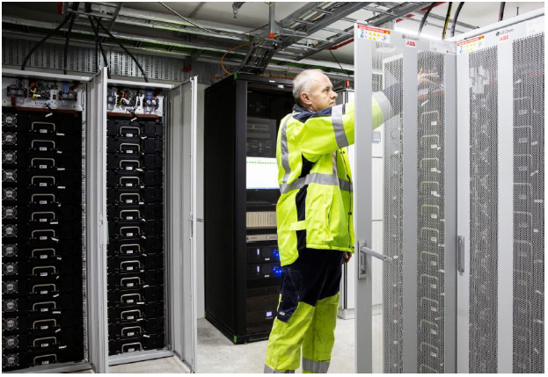 | Energylab Nordhavn, Copenhagen, Denmark | Frequency Regulation  Peak Shaving  Voltage Regulation  Harmonic Filtering | 2017 | 630 kW  460 kWh  NMC | ABB for Radius Elnet / Ørsted | [42]
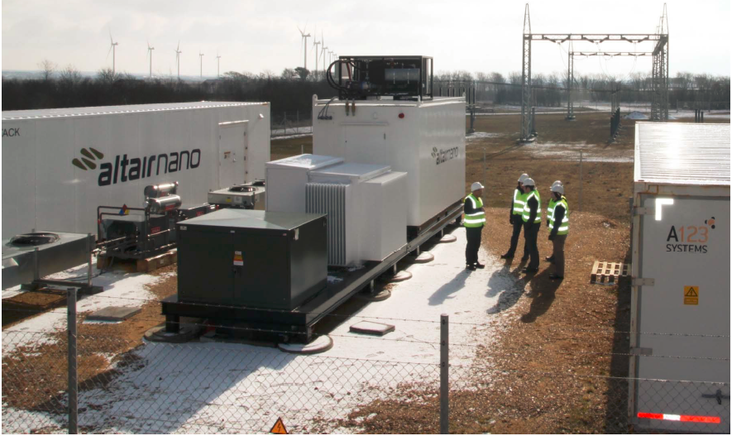 | Lem Kær Wind Farm,  Denmark | Frequency regulation | 2014 | 400kW LFP and 1.2MW LTO | Altairnano and A123 for Vestas | [43]
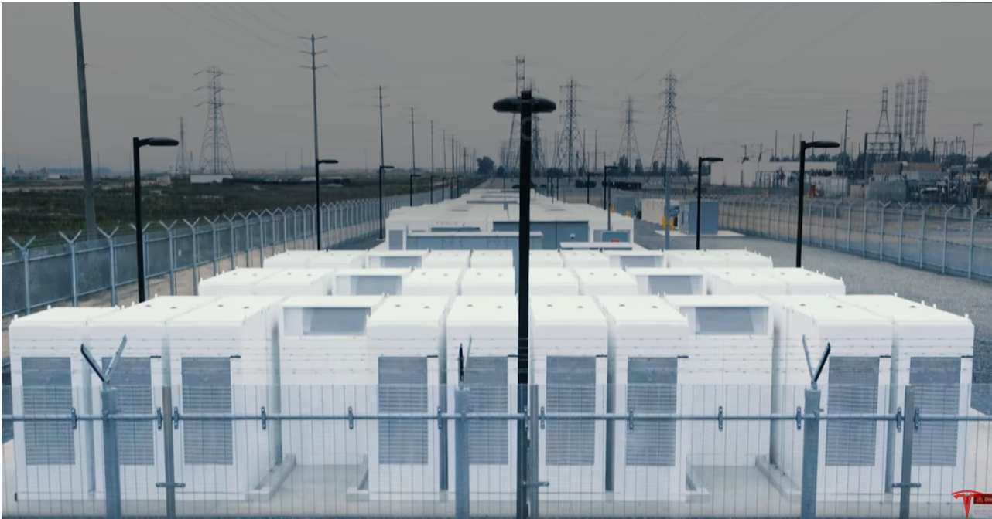 | Mira Loma Substation, California, USA | Peak Shaving | 2016 | 20  MW  80  MWh | Tesla | [38,39]
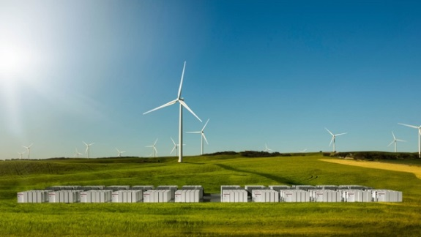 | Neoen’s Hornsdale Wind Farm,  South Australia | Peak Shaving | 2017 | 100  MW  129 MWh | Tesla | [40]
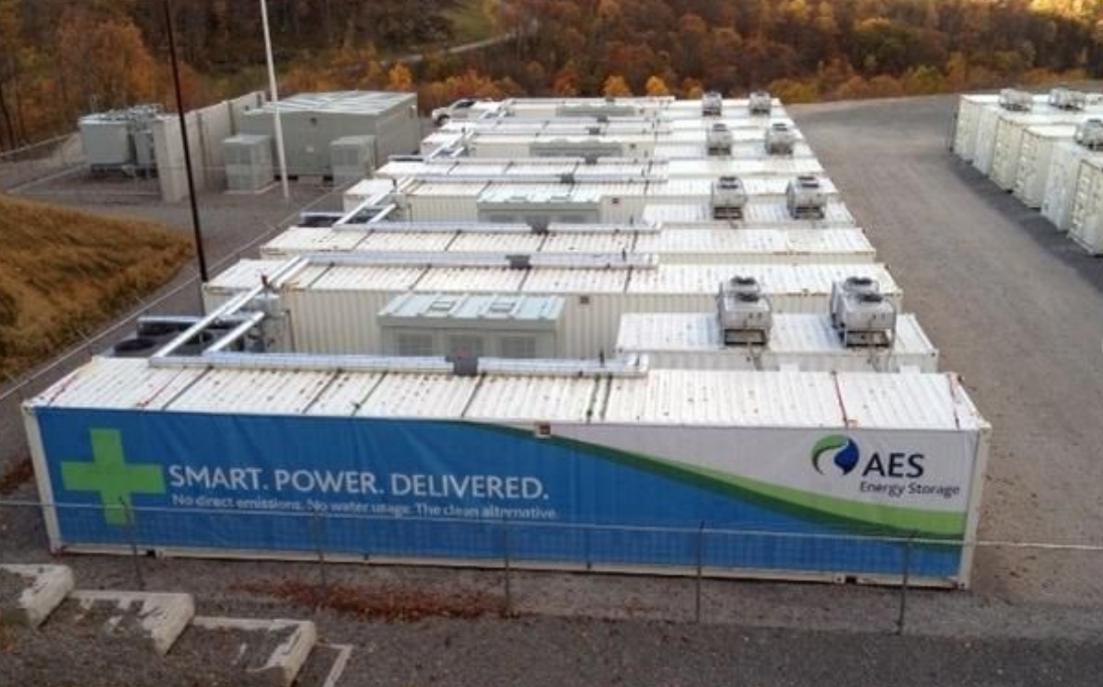 | Laurel Mountain,  Belington, West Virginia,  USA | Frequency Regulation and Renewable Energy Integration | 2011 | 32  MW  8  MWh | AES and A123 | [41]

Prediction of performance and cost
The recent industry average LIB pack cost forecast taken from Bloomberg’s New Energy Outlook 2018 is shown in Figure 8 [44]. The current LIB price is close to 200$/kWh and the forecast (dotted line) predicts a battery price of 70 $/kWh by 2030. Further, the forecasted added installed capacity between now and 2050 is estimated to 1291 GW [44]. Using Bloombergs 18% learning rate and the predicted capacity growth, this results in a forecasted 50$/kWh in 2040 and 40 $/kWh in 2050.
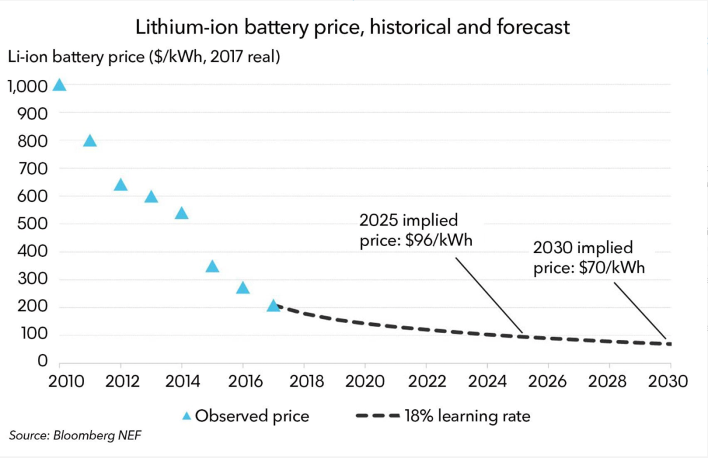
Figure 8: Historical and forecasted Lithium-ion battery pack cost [44].

TESLA through its Gigafactory is reported to be 4-5 years ahead of the industry average with a pack cost level of US$190/kWh already in 2016 and indications have been reported of US$ 100/kWh before 2020 [45] and US$ 80/kWh soon thereafter [46].
The cost reductions are backed up by a rapid increase in the LIB production capacity as shown in Figure 9. The production capacity is expected to grow from 28 GWh in 2016 to 174 GWh by 2020 representing an impressive five-fold growth in four years [47].

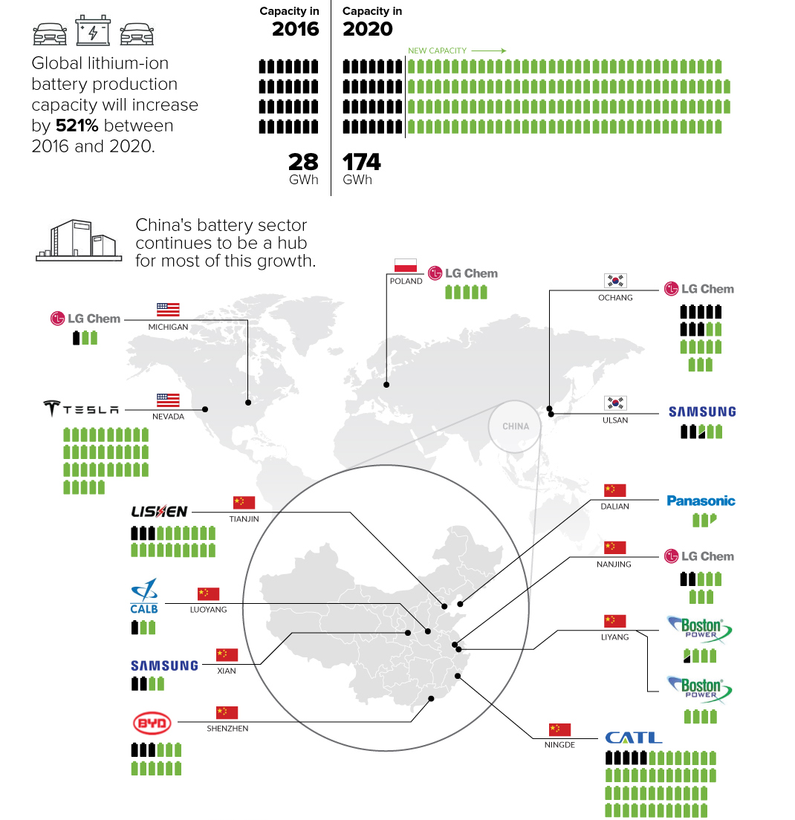
Figure 9: Projected growth in LIB manufacturing capacity over next few years, total and divided on technology producers [47]. Each battery represents a production capacity of one GWh per year.

The forecasted decrease in battery pack cost (Figure 8) and increase in production capacity (Figure 9) aligns with a forecasted steep growth rate of the utility-scale application market as shown in Figure 10. The installed capacity is estimated to reach 14 GW in 2023 [48]. Globaldata predicts this capacity level could be reached already in 2020 [49].

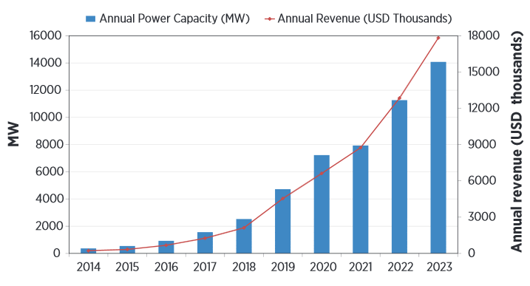
Figure 10: Worldwide forecast of battery storage capacity (MW) and annual revenue (USD) for utility-scale applications [48].

Uncertainty
The LIB price forecasts imply a broad range of uncertainties. If the learning rate is not 18% as estimated in Bloomberg’s New Energy Outlook 2018 [44], but rather 12-16% as estimated earlier [50], the forecasted price reductions will be smaller. Having a 12% learning rate, the 2050 price ends at 70 $/kWh instead of 40 $/kWh. With a 14% and 16% learning rate the 2050 price ends respectively at 60 $/kWh and 50 $/kWh.
As shown in Figure 11 Tesla/Panasonic seems 4 to 5 years ahead of the industry average cost per kWh. The figure also indicates differences in the forecasted cost reduction. The Tesla forecast indicates pack prices as low as 50 $/kWh already in 2025.
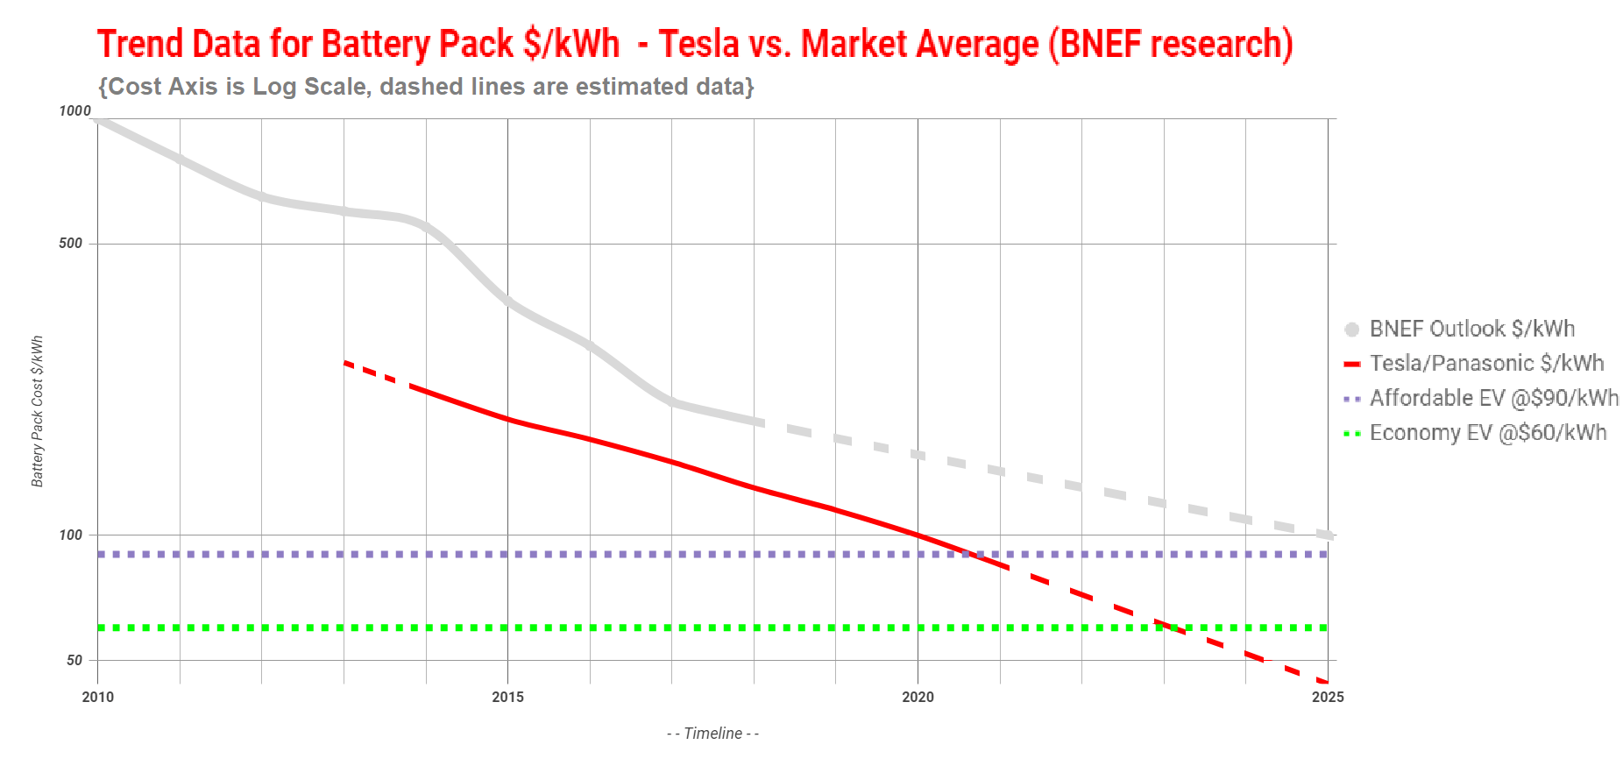
Figure 11: Trend data for Tesla/Panasonic vs. Bloombergs forecasts for LIB pack cost [44,45].

The spread in the current and predicted price shown in Figure 11 indicates a substantial uncertainty in the current and forecasted cost. The estimated 90% confidence interval is 170-80 $/kWh in 2020 and for the 2050 LIB price is estimated to be 30-75 $/kWh.

Data sheet
The data sheet table summarizes the development predictions. The assumptions for the predictions are discussed in the sections above.
Technology |  |  |  | Lithium-ion battery (Utility-scale)
 |  | 2015 | 2020 |  | 2030 | 2040 | 2050 | Uncertainty (2020) |  | Uncertainty  (2050) |  | Note | Ref
Energy/technical data |  |  |  |  |  |  |  | Lower | Upper | Lower | Upper
Form of energy stored |  |  | Electricity
Application |  |  | System, power- and energy-intensive
Energy storage capacity for one unit (MWh) |  | 3.2 | 6 |  | 7 | 8 | 8 | 5 | 9 | 7 | 12 | A | [2,14]
Output capacity for one unit (MW) |  | 9.6 | 18 |  | 21 | 24 | 24 | 16 | 21 | 22 | 28 | A,B | [2,14]
Input capacity for one unit (MW) |  | 9.6 | 18 |  | 21 | 24 | 24 | 16 | 21 | 22 | 28 | A,B | [2,14]
Round trip efficiency (%) AC |  | 91 | 91 |  | 92 | 92 | 92 | 90 | 92 | 91 | 94 | C | [3,21,22,51]
Round trip efficiency (%) DC |  | 95 | 95 |  | 96 | 96 | 96 | 95 | 96 | 95 | 97 | C | [3,21,22,51]
- Charge efficiency (%) |  | 98 | 98 |  | 98.5 | 98.5 | 98.5 | 98 | 98.5 | 98 | 99 | D | [2]
- Discharge efficiency (%) |  | 97 | 97 |  | 97.5 | 97.5 | 97.5 | 97 | 98 | 97 | 98 | D | [2]
Energy losses during storage (%/day) |  | 0.1 | 0.1 |  | 0.1 | 0.1 | 0.1 | 0.05 | 0.2 | 0.05 | 0.15 | E | [18,50,52]
Forced outage (%) |  | 0.4 | 0.38 |  | 0.35 | 0.3 | 0.25 | 0.2 | 0.5 | 0.1 | 0.3 | F
Planned outage (weeks per year) |  | 0.2 | 0.2 |  | 0.1 | 0.1 | 0.1 | 0.1 | 0.25 | 0.05 | 0.2 | F
Technical lifetime (years) |  | 15 | 20 |  | 25 | 30 | 30 | 15 | 25 | 20 | 45 | G | [3,5,8,14]
Construction time (years) |  | 0.25 | 0.2 |  | 0.2 | 0.2 | 0.2 | 0.2 | 0.25 | 0.1 | 0.25
 | Regulation ability
Response time from idle to full-rated discharge (sec) |  | <0.08 | <0.08 |  | <0.08 | <0.08 | <0.08 | <0.08 | <0.08 | <0.08 | <0.08 | H | [53]
Response time from full-rated charge to full-rated discharge (sec) |  | <0.08 | <0.08 |  | <0.08 | <0.08 | <0.08 | <0.08 | <0.08 | <0.08 | <0.08 | H | [53]
 | Financial data
Specific investment (M€2015 per MWh) |  | 0.769 | 0.330 |  | 0.154 | 0.110 | 0.088 | 0,176 | 0,374 | 0,066 | 0,165 | I | [44,48]
- energy component (M€/MWh) |  | 0.308 | 0.132 |  | 0.062 | 0.044 | 0.035 | 0,070 | 0.149 | 0.026 | 0.066 | J | [44]
- capacity component (M€/MW) PCS |  | 0.29 | 0.27 |  | 0.20 | 0.16 | 0.13 | 0.24 | 0.51 | 0.10 | 0,25 | K | [54–56]
- other project costs (M€/MWh) |  | 0.11 | 0.11 |  | 0.11 | 0.11 | 0.11 | 0.09 | 0.11 | 0.07 | 0.11 | L | [22,40,54]
Fixed O&M (k€2015/MW/year) |  | 0.54 | 0.54 |  | 0.54 | 0.54 | 0.54 | 0.45 | 0.54 | 0.40 | 0.54 | M | [22]
Variable O&M (€2015/MW/year) |  | 0 | 0 |  | 0 | 0 | 0 | 0 | 0 | 0 | 0 | N
 | Technology specific data
Energy storage expansion cost (M€2015/MWh) |  | 0.769 | 0.330 |  | 0.154 | 0.110 | 0.088 | 0,176 | 0,374 | 0,066 | 0,165 | O | [44,48]
Output capacity expansion cost (M€2015/MW) |  | 0.29 | 0.27 |  | 0.20 | 0.16 | 0.13 | 0.24 | 0.51 | 0.10 | 0,25 | P | [54–56]
Alternative Investment cost (M€2015/MW) |  | 0.48 | 0.35 |  | 0.24 | 0.19 | 0.15 | 0.28 | 0.6 | 0.12 | 0.29 | Q | [41,44,48,54–56]
Lifetime in total number of cycles |  | 6000 | 14000 |  | 30000 | 40000 | 50000 | 10000 | 16000 | 20000 | 70000 | R | [3–5,14]
Specific power (W/kg) |  | 569 | 700 |  | 900 | 1000 | 1200 | 600 | 900 | 1000 | 2000 | S | [2,24]
Power density (kW/m3) |  | 708 | 800 |  | 1000 | 1200 | 1400 | 750 | 900 | 1200 | 2000 | S | [2,24]
Specific energy (Wh/kg) |  | 95 | 105 |  | 139 | 174 | 209 | 100 | 140 | 150 | 300 | S | [2,24]
Energy density (kWh/m3) |  | 118 | 130 |  | 173 | 216 | 260 | 150 | 200 | 200 | 400 | S | [2,24]
** 1 € = 1.14 US$

Data Sheet Notes:
- One unit defined as a 40 feet container including LIB system and excluding power conversion system. Values for 2015-2030 are taken from Samsung SDI brochures for grid-connected LIBs from 2016 and 2018 [2,14].
- Power output are set to 3 times the energy capacity as it is the standard grid-connected LIBs designed for power purposes [2,14].
- The average DC roundtrip efficiency is expected to increase slightly as the storage cost in $/kWh decreases since this promotes operation at lower C-rates. The RT eff. vs. C-rate is exemplified in Figure 7 [3,51]. The AC roundtrip efficiency includes losses in the power electronics and is 2-4% lower than the DC roundtrip efficiency. The total roundtrip efficiency further includes standby losses making the total roundtrip efficiency typically ranging between 80% and 90% [21,22].
- The C-rate is 0.5 during charge and up to 6 during discharge for the Samsung SDI batteries [2]. The presented conversion efficiencies assume average discharge C-rates in 2015-2020 around 2.5 and charge C-rates around 0.5.
- Lithium-ion battery daily discharge loss. The central estimates for self-discharge of Li-ion batteries range between 0.05% and 0.20% a day in 2016 and are expected to stay flat to 2030.
- It is expected not to have any outage during lifetime of the grid-connected LIB. Only a few days during the e.g. 15 years life time is needed for service and exchanging fans and blowers for thermal management system and power conversion system. Forced outage is expected to drop with increasing robustness following the learning rate and cumulated production. Planned outage is expected to decrease after 2020 due to increased automation.
- Current state-of-the-art NMC LIB has 20 years lifetime. The NMC lifetime is expected to reach LTO lifetime by 2020 and 30 years lifetime for grid-connected LIBs in 2040 and 2050 as photovoltaic power systems have today [3,5,8,14].
- The response time is obtained from simulated response time experiments with hardware in the loop [53].
- The forecast of the system specific investment cost is estimated as 2.5 times the battery forecast. The forecast is exclusive power cables to the site and entrepreneur work for installation of the containers [44,48].
- The battery pack cost forecast is provided in Figure 8 and the related text [44].
- Power conversion cost is strongly dependent on scalability and application. The PCS cost is based on references [54–56] and reflects the necessity for high power performance and compliance to grid codes to provide ancillary services, bidirectional electricity flow and two-stage conversion, as well as the early stage of development and the fact that few manufacturers can guarantee turnkey systems.
- Other costs include construction costs and entrepreneur work. These costs heavily dependent on location, substrate and site access. Estimates are aggregated from the literature [22,40,54]
- Inverter replacement is expected every 10 years [22].
- No variable O&M is assumed since the LIB storage system is stand-alone.
- Since multi-MWh LIB systems are scalar, the energy storage expansion cost equals the Specific investment cost [44,48].
- Since multi-MW LIB systems are scalar, the capacity expansion cost equals the capacity component cost [54–56].
- The alternative investment cost in M€2015/MW is specified for a 4C, 0.25 h system as for the Laurel Mountain, West Virginia, USA grid-scale LIB storage system [41]. I.e. the alternative investment cost is 25% of the energy storage expansion cost plus the PCS cost [41,44,48,54–56].
- Cycle life specified as the number of cycles at 1C/1C to 80% state-of-health. Samsung SDI 2016 whitepaper on ESS solutions provide 15 year lifetime for current modules operating at C/2 to 3C [14]. Steady improvement in battery lifetime due to better materials and battery management is expected. Kokam ESS solutions are also rated at more than 8000-20000 cycles (80-90% DOD) based on chemistry [3]. Thus for daily full charge-discharge cycles, the batteries are designed to last for 15-50 years if supporting units are well functioning. Lifetimes are given for both graphite and LTO anode based commercial batteries from Kokam. Cycle lives are steadily increasing over last few years as reflected in 2020/2030 numbers [4,5,14].
- Specific power, power density, Specific energy and energy density is provided for discharge mode, starting with the values provided in the section “Typical characteristics and capacities”. A charge/discharge conversion factor of 12 can be derived from this section. The expected development depends on the successive R&D progress as indicated in the section “Research and development perspectives” [2,24].

Acknowledgement
Arghya Bhowmik, DTU is acknowledged for inspiration via a previous draft of the technology.

References
[1] Leclanche. Lithium Ion Technology and Product Description, (2018). http://www.leclanche.com/technology-products/leclanche-technology/lithium-ion-cells/
[2] Samsung. ESS Batteries by Samsung SDI Top Safety & Reliability Solutions, (2018). http://www.samsungsdi.com/upload/ess_brochure/201809_SamsungSDI ESS_EN.pdf
[3] L. Kokam Co. Total Energy Storage Solution Provider, (2018). http://kokam.com/data/2018_Kokam_ESS_Brochure_ver_5.0.pdf
[4] L. Kokam Co. Kokam Li-ion / Polymer Cell, (2017). http://kokam.com/data/Kokam_Cell_Brochure_V.4.pdf
[5] StoraXe. StoraXe Industrial & Infrastructure Scalable battery storage system, (2018). https://www.ads-tec.de/fileadmin/download/doc/brochure/Datasheet_Energy_Industrial_EN.pdf
[6] Fronius. Fronius Energy Package, (2018). http://www.fronius.com/en/photovoltaics/products/all-products/solutions/fronius-storage-solution/fronius-energy-package/fronius-energy-package
[7] Fenecon. Fenecon Commercial 50-series Battery Module | Battery Rack, (2018). https://www.fenecon.de/en_US/page/infocenter#fenecon-industrial
[8] Altairnano. 24 V 60 Ah Battery Module, (2016). https://altairnano.com/products/battery-module/
[9] S. Weintraub, Electrek. Tesla Gigafactory tour roundup and tidbits: ‘This is the coolest factory in the world’, (2016). https://electrek.co/2016/07/28/tesla-gigafactory-tour-roundup-and-tidbits-this-is-the-coolest-factory-ever/
[10] M. Kane, InsideEVs. BMW i3 Samsung SDI 94 Ah Battery Rated For 524,000 Miles, (2018). https://insideevs.com/lets-look-at-the-specs-of-the-samsung-sdi-94-ah-battery/
[11] Qnovo. Inside the Battery of a Nissan Leaf, (2018). https://qnovo.com/inside-the-battery-of-a-nissan-leaf/
[12] J.M. Tarascon, M. Armand. Issues and challenges facing rechargeable lithium batteries, Nature, 414 (2001) 359. doi:10.1038/35104644
[13] Shutterstock. Tesla 2170 battery cell stock photos, (2018). https://www.shutterstock.com/search/tesla+2170+battery+cell
[14] Samsung, Smart Battery Systems for Energy Storage, (2016). http://www.samsungsdi.com/upload/ess_brochure/Samsung SDI brochure_EN.pdf
[15] Inside EVs. LCChem Prismatic Cell, (2018). https://insideevs.com/wp-content/uploads/2015/12/ess_cell1.jpg
[16] H.C. Hesse, M. Schimpe, D. Kucevic, A. Jossen. Lithium-ion battery storage for the grid - A review of stationary battery storage system design tailored for applications in modern power grids, Energies, 10 (2017) 2107. doi:10.3390/en10122107
[17] M. Schimpe, M. Naumann, N. Truong, H.C. Hesse, S. Santhanagopalan, A. Saxon, A. Jossen. Energy efficiency evaluation of a stationary lithium-ion battery container storage system via electro-thermal modeling and detailed component analysis, Appl. Energy. 210 (2018) 211. doi:10.1016/j.apenenergy.2017.10.129
[18] Electropaedia. Battery Performance Characteristics - How to specify and test a battery, (2018). https://www.mpoweruk.com/performance.htm
[19] L. Kokam Co. Lithium Ion Polymer Cells - High Energy High PowerㅣKokam Battery Cells, (2018). http://kokam.com/cell/
[20] Sempra Renewables. Auwahi Wind, (2012). http://www.semprarenewables.com/project/auwahi-wind/
[21] A.H. Fathima, K. Palanisamy. Renewable systems and energy storages for hybrid systems, Ed(s): A. Hina Fathima, et al., in Hybrid-renewable energy systems in microgrids. Woodhead Publishing (2018), pp. 162. https://doi.org/10.1016/B978-0-08-102493-5.00008-X
[22] Lazard. Levelized Cost of Storage (2017)., https://www.lazard.com/perspective/levelized-cost-of-storage-2017/
[23] R. Hidalgo-León et al. A survey of battery energy storage system (BESS), applications and environmental impacts in power systems, 2017 IEEE 2nd ETCM pp. 1–6. doi:10.1109/etcm.2017.8247485.
[24] LG Chem. Change your energy. Change your life., (2018). http://www.lgchem.com/upload/file/product/LGChem_Catalog_Global_2018.pdf
[25] Researchinterfaces. Lithium-ion batteries for large-scale grid energy storage, (2018). https://researchinterfaces.com/lithium-ion-batteries-grid-energy-storage/
[26] U.S. EPA. Application of Life-Cycle Assessment to Nanoscale Technology: Lithium-ion Batteries for Electric Vehicles, United States Environ. Prot. Agency. (2013) 1–119. doi:10.1038/nchem.2085.
[27] J.F. Peters, M. Baumann, B. Zimmermann, J. Braun, M. Weil. The environmental impact of Li-Ion batteries and the role of key parameters – A review, Renew. Sustain. Energy Rev. 67 (2017) 491–506. doi:10.1016/j.rser.2016.08.039
[28] The Washington Post. The environmental impact of cobalt mining, (2018). https://www.washingtonpost.com/news/in-sight/wp/2018/02/28/the-cost-of-cobalt/?utm_term=.eebc6c00f0de
[29] Visualcapitalist. Nickel: The Secret Driver of the Battery Revolution, (2017). http://www.visualcapitalist.com/nickel-secret-driver-battery-revolution/
[30] Bloomberg. We’re Going to Need More Lithium, (2017). https://www.bloomberg.com/graphics/2017-lithium-battery-future/
[31] R. Petibon, J. Xia, L. Ma, M.K.G. Bauer, K.J. Nelson, J.R. Dahn. Electrolyte System for High Voltage Li-Ion Cells, J. Electrochem. Soc. 163 (2016) A2571–A2578. doi:10.1149/2.0321613jes
[32] A. Casimir, H. Zhang, O. Ogoke, J.C. Amine, J. Lu, G. Wu. Silicon-based anodes for lithium-ion batteries: Effectiveness of materials synthesis and electrode preparation, Nano Energy. 27 (2016) 359–376. doi:10.1016/j.nanoen.2016.07.023
[33] M. Saulnier, A. Auclair, G. Liang, S.B. Schougaard. Manganese dissolution in lithium-ion positive electrode materials, Solid State Ionics. 294 (2016) 1–5. doi:10.1016/j.ssi.2016.06.007
[34] E.-Y. Kim, B.-R. Lee, G. Yun, E.-S. Oh, H. Lee. Effects of binder content on manganese dissolution and electrochemical performances of spinel lithium manganese oxide cathodes for lithium ion batteries, Curr. Appl. Phys. 15 (2015) 429–434. doi:10.1016/j.cap.2015.01.029
[35] S. Lee, E.-Y. Kim, H. Lee, E.-S. Oh. Effects of polymeric binders on electrochemical performances of spinel lithium manganese oxide cathodes in lithium ion batteries, J. Power Sources. 269 (2014) 418–423. doi:10.1016/j.jpowsour.2014.06.167
[36] eeNews Power Management. Revolutionary solid state rechargeable aluminium-sulfur battery project starts, (2017). http://www.eenewspower.com/news/revolutionary-solid-state-rechargeable-aluminium-sulfur-battery-project-starts
[37] Ørsted. Ørsted takes first steps into commercial energy storage, (2018). https://orsted.com/en/Media/Newsroom/News/2018/04/Orsted-takes-first-steps-into-commercial-battery-storage
[38] Tesla. Addressing Peak Energy Demand with the Tesla Powerpack, (2016). https://www.tesla.com/da_DK/blog/addressing-peak-energy-demand-tesla-powerpack?redirect=no
[39] Electrek. Tesla quietly brings online its massive - biggest in the world - 80 MWh Powerpack station with Southern California Edison, (2017). https://electrek.co/2017/01/23/tesla-mira-loma-powerpack-station-southern-california-edison/
[40] Tesla. Tesla Powerpack to Enable Large Scale Sustainable Energy to South Australia, (2017). https://www.tesla.com/da_DK/blog/Tesla-powerpack-enable-large-scale-sustainable-energy-south-australia?redirect=no Page
[41] Energy Storage Association. Frequency Regulation Services and a Firm Wind Product: AES Energy Storage Laurel Mountain Battery Energy Storage, (2018). http://energystorage.org/energy-storage/case-studies/frequency-regulation-services-and-firm-wind-product-aes-energy-storage
[42] ABB. Battery energy storage system PQpluS, (2018). https://new.abb.com/high-voltage/capacitors/lv/bess-products/PQpluS
[43] S. Saylors, Philip C. Kjær. Rasmus Lærke. Ancillary Services Provided from Wind Power Plant Augmented with Energy Storage, (2014). https://www.ieee-pes.org/presentations/gm2014/PESGM2014P-000718.pdf
[44] Bloomberg New Energy Finance. New Energy Outlook 2018, (2018). https://bnef.turtl.co/story/neo2018.pdf?autoprint=true&teaser=true
[45] CleanTechnica. $100/kWh Tesla Battery Cells This Year, $100/kWh Tesla Battery Packs In 2020|, (2018). https://cleantechnica.com/2018/06/09/100-kwh-tesla-battery-cells-this-year-100-kwh-tesla-battery-packs-in-2020/
[46] Wardsauto. Two Tidbits From CES: Better Cybersecurity and Cheaper EV Batteries, (2017). https://www.wardsauto.com/ideaxchange/two-tidbits-ces
[47] Visualcapitalist. China Leading the Charge for Lithium-Ion Megafactories, (2017) http://www.visualcapitalist.com/china-leading-charge-lithium-ion-megafactories/
[48] International Renewable Energy Agency. IRENA Battery Storage Report, (2015). http://www.irena.org/-/media/Files/IRENA/Agency/Publication/2015/IRENA_Battery_Storage_report_2015.pdf
[49] Windpower Engineering & Development. Global battery energy-storage system installed capacity will exceed 14 GW by 2020, (2016). https://www.windpowerengineering.com/business-news-projects/global-battery-energy-storage-system-installed-capacity-will-exceed-14-gw-2020/
[50] International Renewable Energy Agency. Electricity Storage and Renewables : Costs and Markets To 2030, (2017). http://www.irena.org/publications/2017/Oct/Electricity-storage-and-renewables-costs-and-markets
[51] Danish Technological Institute. BESS project Smart grid ready Battery Energy Storage System for future grid, (2017). https://www.energiforskning.dk/sites/energiteknologi.dk/files/slutrapporter/bess_final_report_forskel_10731.pdf
[52] H. Chen, T.N. Cong, W. Yang, C. Tan, Y. Li, Y. Ding, Progress in electrical energy storage system: A critical review, Prog. Nat. Sci. 19 (2009) 291–312. doi:10.1016/j.pnsc.2008.07.014
[53] D.M. Greenwood, K.Y. Lim, C. Patsios, P.F. Lyons, Y.S. Lim, P.C. Taylor, Frequency response services designed for energy storage, Appl. Energy. 203 (2017) 115–127. doi:10.1016/j.apenergy.2017.06.046
[54] R. Benato, G. Bruno, F. Palone, R.M. Polito, M. Rebolini, Large-scale electrochemical energy storage in high voltage grids: Overview of the Italian experience, Energies. 10 (2017) 1-17. doi:10.3390/en10010108
[55] B. Zakeri, S. Syri, Electrical energy storage systems: A comparative life cycle cost analysis, Renew. Sustain. Energy Rev. 42 (2015) 569–596. doi:10.1016/j.rser.2014.10.011
[56] G. Huff, A.B. Currier, B.C. Kaun, D.M. Rastler, S.B. Chen, D.T. Bradshaw, W.D. Gauntlett, DOE/EPRI electricity storage handbook in collaboration with NRECA, (2015). https://www.sandia.gov/ess-ssl/publications/SAND2015-1002.pdf

FCR-N: Frequency Containment Reserve for Normal operation. FCR-D: Frequency Containment Reserve for Disturbances

